## Movie Booking Website

Submitted for partial fulfilment for Diploma in MEAN Stack



By

Sumon Karmakar

Student id:- S170050100109

Reg No:- R170050100537

-:Index:-

Requirement Specification:-

The main purpose of my project is to book ticket. Here first of all I have to add the movie. For this I need city and in which city and in which city the theatre is located. After adding city and theatre I have to add the movies to our project. Now I can add movie to the project. After adding movie there I have to add theatre, and Showtime. In this way I can totally add the different functionality of the project. And ultimately all the functionality of the project is done.

Architecture of different collection schema:-

***Movie Collection:-***

|  |  |
| --- | --- |
| *Field Name* | *Data Type* |
| *ID* | *ObjectId("58aa7f7aa3edc20c1b045eb2")* |
| *Title* | *Kaabil* |
| *Year* | *2017* |
| *Rated* | *N/A* |
| *Released* | *25 Jan 2017* |
| *Runtime* | *N/A* |
| *Genre* | *Action, Drama, Romance* |
| *Director* | *Sanjay Gupta* |
| *Writer* | *Sanjay Masoom (dialogue), Vijay Kumar Mishra* |
| *Actors* | *Hrithik Roshan, Yami Gautam, Ronit Roy, Rohit Roy* |
| *Plot* | *A blind man sets out to avenge the murder of his girlfriend.* |
| *Language* | *Hindi* |
| *Country* | *India* |
| *Awards* | *N/A* |
| *Poster* | *https://images-na.ssl-images-amazon.com/images/M/MV5BNGU0MDM1ODgtZmMwNi00NWRiLTgxYWEtMjJlNjMxNjc1NzQzL2ltYWdlL2ltYWdlXkEyXkFqcGdeQXVyNDkxMzY0Mjk@._V1_SX300.jpg* |
| *Metascore* | *N/A* |
| *imdbRating* | *N/A* |
| *imdbVotes* | *N/A* |
| *imdbID* | *tt5460276* |
| *Type* | *movie* |
| *Response* | *True* |
|  |  |

***City Collection:-***

|  |  |
| --- | --- |
| ***FieldName*** | ***DataType*** |
| CityName | *Goa* |

***Theatre Collection:-***

|  |  |
| --- | --- |
| ***FieldName*** | ***DataType*** |
| theatreName | Inox |
| theatreCity | Kolkata |
| theatreAddress | Esplanade |
| theatreContact | 123 |

***ShowMapping Collection:-***

|  |  |
| --- | --- |
| ***FieldName*** | ***DataType*** |
| Id |  |
| Theatre |  |
| Movie |  |
| fromDate |  |
| toDate |  |
| slot |  |

***Booking Collection:-***

|  |  |
| --- | --- |
| ***FieldName*** | ***Data Type*** |
| ***Show*** |  |
| ***BookingDate*** |  |
| ***ShowDate*** |  |
| ***ShowTime*** |  |
| ***TotalPrice*** |  |
| ***Seats*** |  |
|  |  |

***Screen Shots of Different Pages of Project:-***

***Home Page:-***

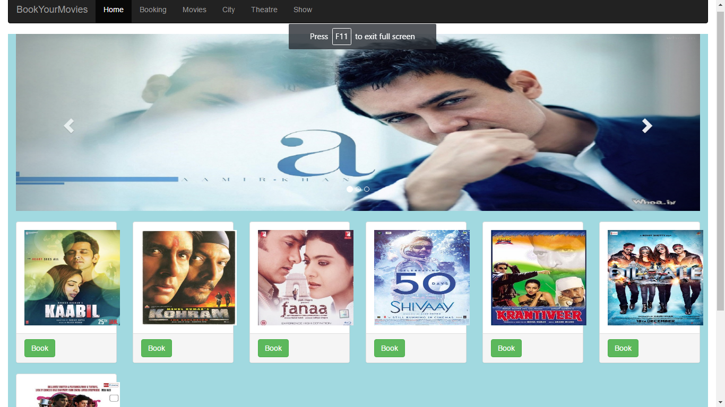

Movie Page:-

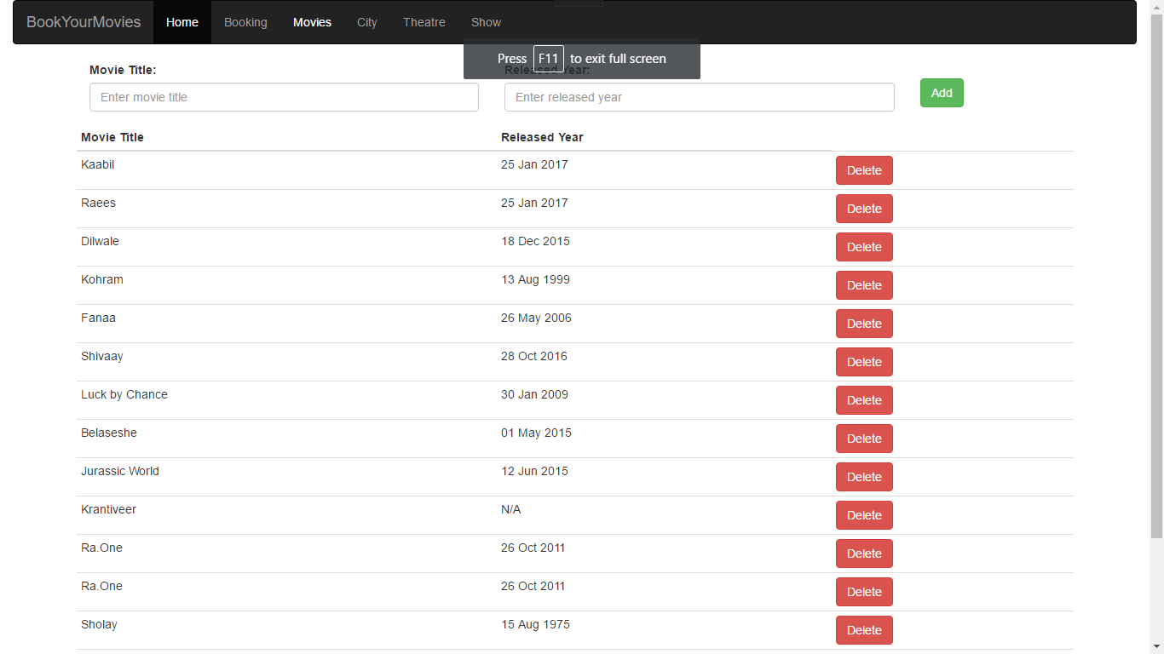

City Page:-

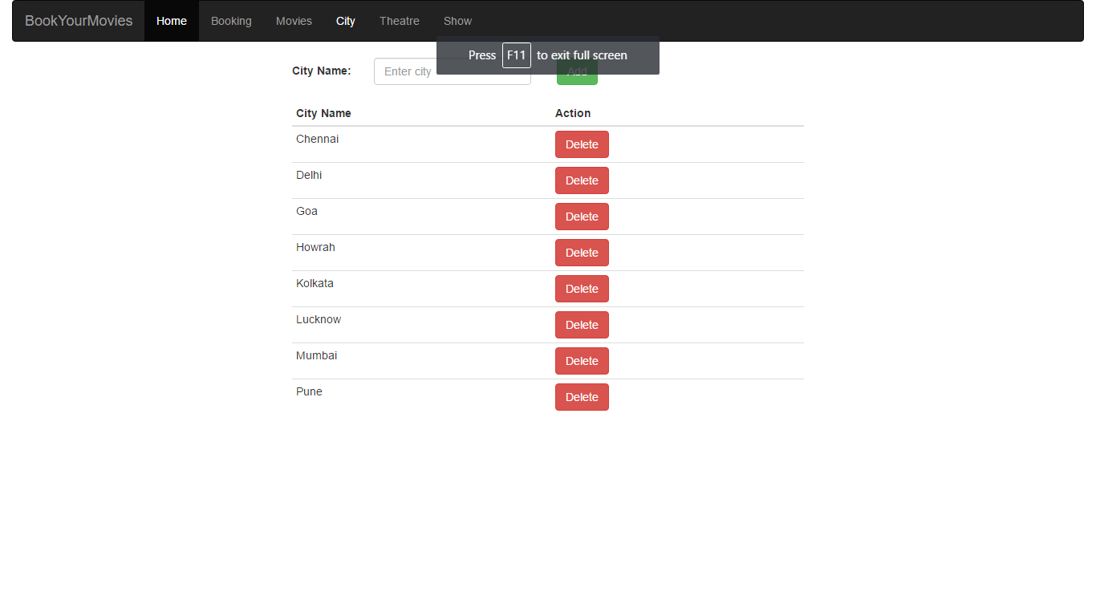

Theatre Page:-

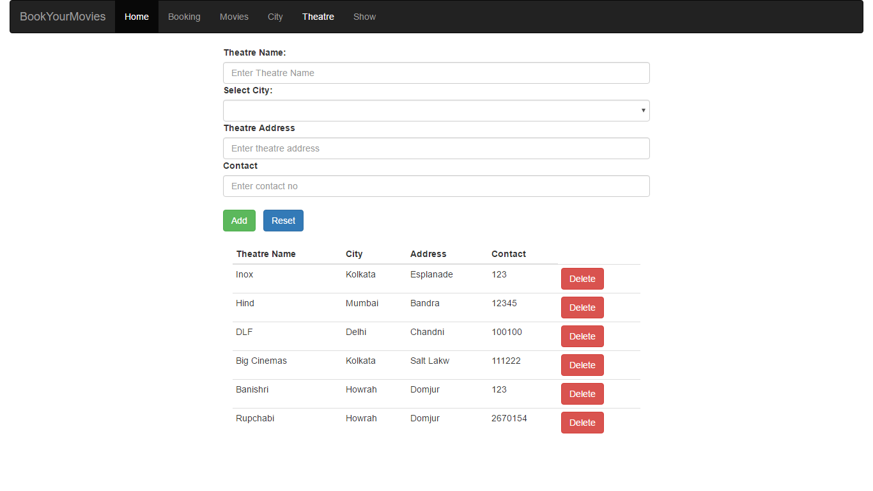

ShowMapping Page:-

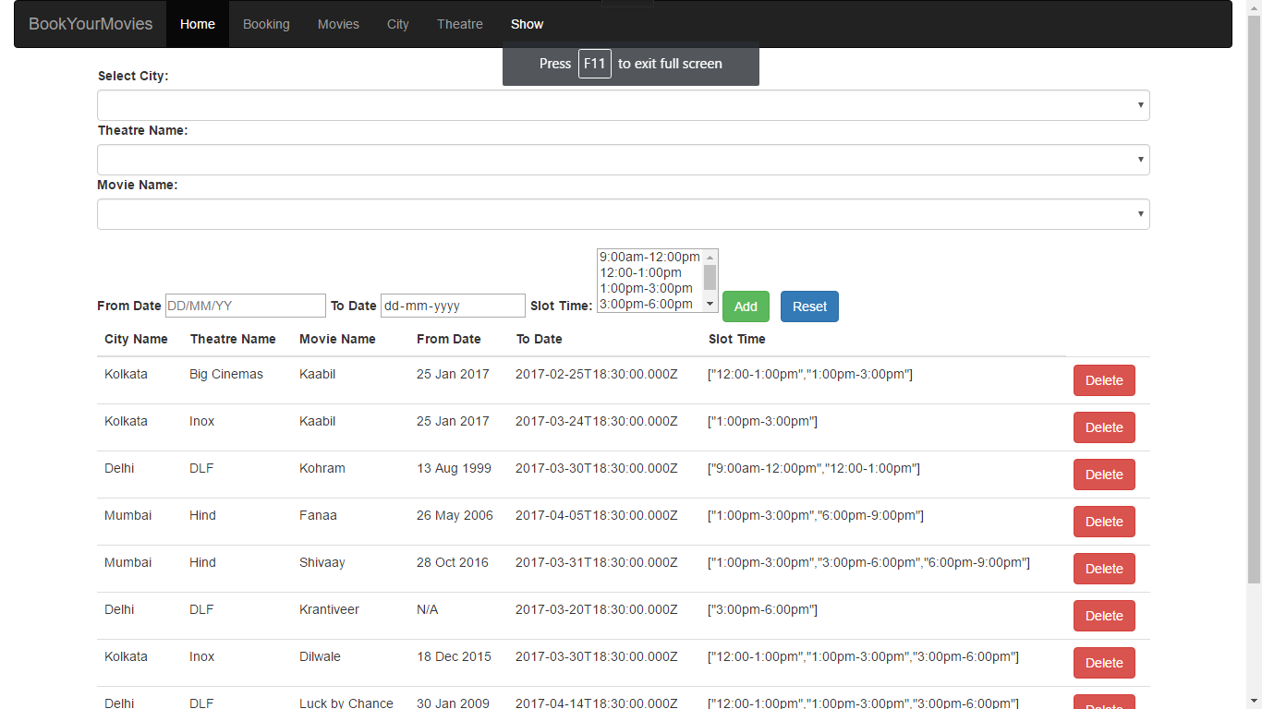

Booking Page:-

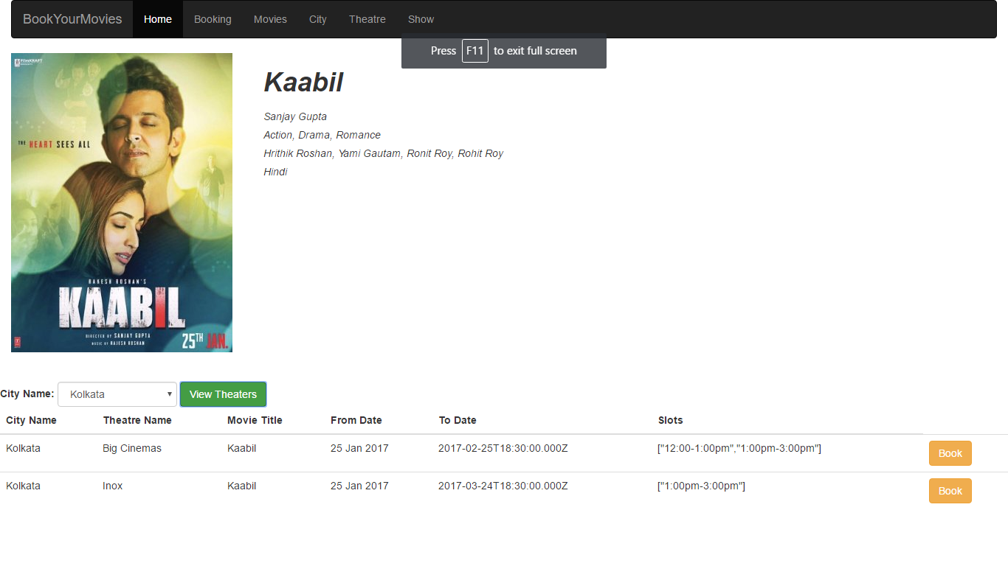

BiblioGraphy:-

1. For Angular js [www.w3schools.com](http://www.w3schools.com)
2. [www.angularjs.org](http://www.angularjs.org)
3. www.javatpoint.com
4. For html,css,bootstrap [www.w3schools.com](http://www.w3schools.com)
5. For mongodb [www.tutorialspoint.com](http://www.tutorialspoint.com)
6. [www.javatpoint.com](http://www.javatpoint.com)